**数据库表结构-用户表、内容表、评论表、广告表**

**Database Table Structure Design**

**DESIGN: Four Tables in database(‘ucca’)**

1. User Table

uid: Unique user identifier (Primary Key)

phone_number: User's bound mobile phone number

avatar: URL or reference to the user's avatar image

nickname: User's chosen nickname

favorites: List of user's favorite items

news_preferences: User's preferences for news

browsing_history: User's history of viewed content

comment_history: User's history of comments

last_login_time: Timestamp indicating the user's last login time

1. Content Table

news_id: Unique identifier for the news (Primary Key)

title: Title of the news

cover_image: URL or reference to the news cover image

publish_datetime: Date and time when the news was published

author: Author of the news

content: Main body text of the news

views: Number of views for the news

favorites: Number of times the news was marked as a favorite

shares: Number of times the news was shared

promoted: Flag indicating whether the news is a paid promotion

1. Comment Table

user_id: User identifier (Foreign Key referencing User Table)

comment_id: Unique identifier for the comment (Primary Key)

news_id: Identifier linking the comment to a specific news (Foreign Key referencing Content Table)

comment_content: Text content of the comment

comment_time: Timestamp indicating when the comment was made

quoted_comment_id: Identifier referencing another comment if applicable

likes: Number of likes the comment received

dislikes: Number of dislikes the comment received

1. Advertisement Table

ad_title: Title of the advertisement

ad_content: Text content of the advertisement

image_link: URL or reference to the advertisement image

placement: Location where the advertisement is displayed (e.g., splash, popup, embedded in homepage list, embedded in comments, embedded in news articles, end of news articles, recommended news embedded)

advertiser_id: Identifier for the advertising party (e.g., client A)

expiration_date: Date when the advertisement will no longer be displayed

region_limit: Geographical regions where the advertisement is allowed

device_limit: Devices on which the advertisement is allowed

clicks: Number of clicks the advertisement received

impressions: Number of times the advertisement was displayed

weight: Weight assigned to control the priority of displaying the advertisement

CODE:

-- User Table

CREATE TABLE User (

uid INT PRIMARY KEY,

phone_number VARCHAR(15),

avatar VARCHAR(255),

nickname VARCHAR(50),

favorites TEXT,

news_preferences TEXT,

browsing_history TEXT,

comment_history TEXT,

last_login_time TIMESTAMP

);

-- Content Table

CREATE TABLE Content (

news_id INT PRIMARY KEY,

title VARCHAR(255),

cover_image VARCHAR(255),

publish_datetime DATETIME,

author VARCHAR(100),

content TEXT,

views INT,

favorites INT,

shares INT,

promoted BOOLEAN

);

-- Comment Table

CREATE TABLE Comment (

user_id INT REFERENCES User(uid),

comment_id INT PRIMARY KEY,

news_id INT REFERENCES Content(news_id),

comment_content TEXT,

comment_time TIMESTAMP,

quoted_comment_id INT,

likes INT,

dislikes INT

);

-- Advertisement Table

CREATE TABLE Advertisement (

ad_title VARCHAR(255),

ad_content TEXT,

image_link VARCHAR(255),

placement VARCHAR(50),

advertiser_id VARCHAR(50),

expiration_date DATE,

region_limit TEXT,

device_limit TEXT,

clicks INT,

impressions INT,

weight INT

);

Screenshot:

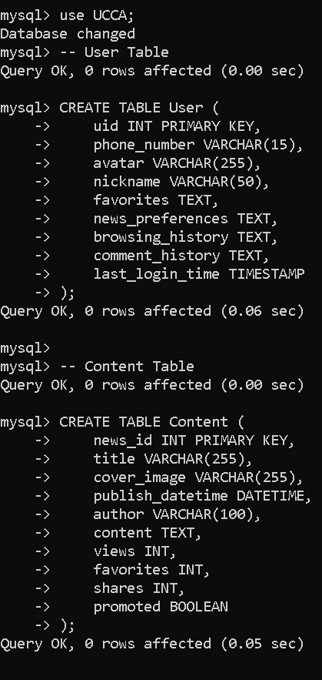

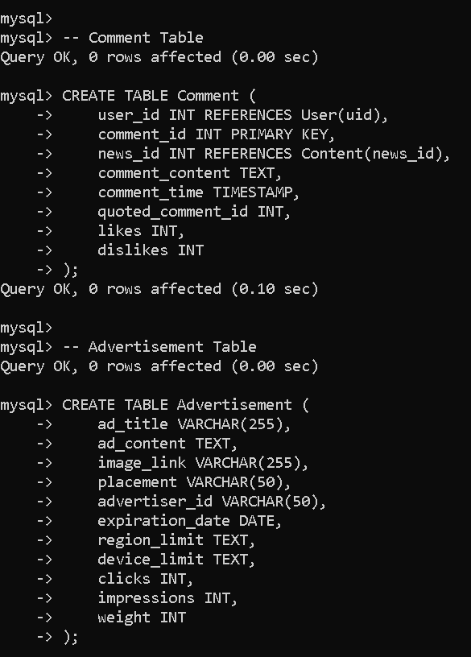

OUTPUT:

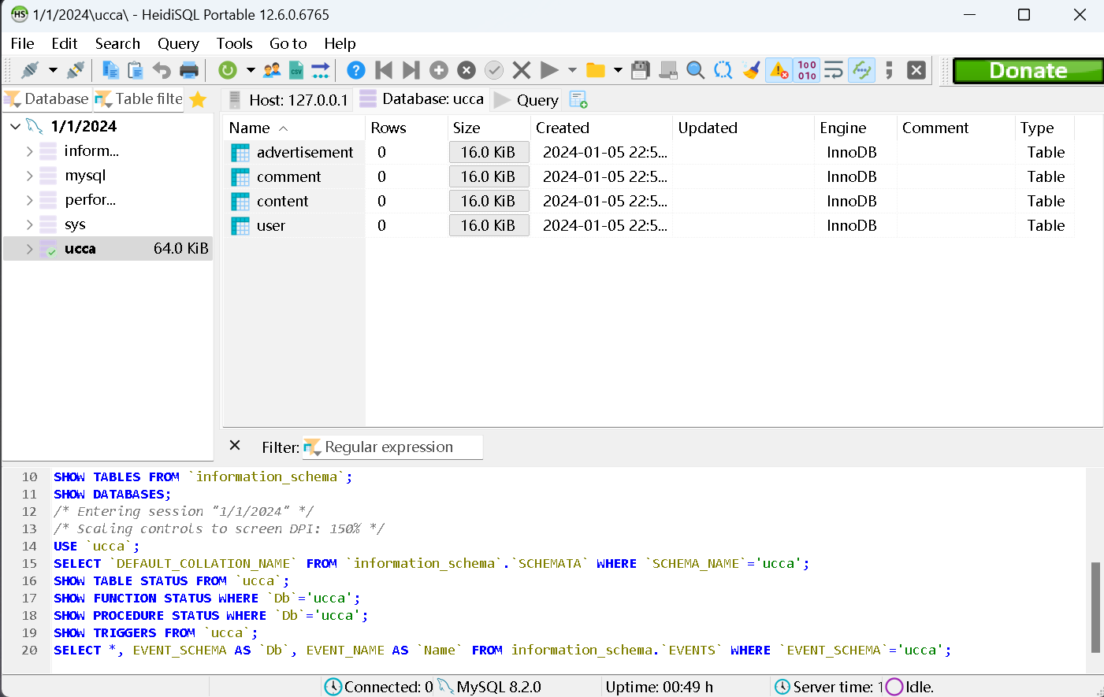

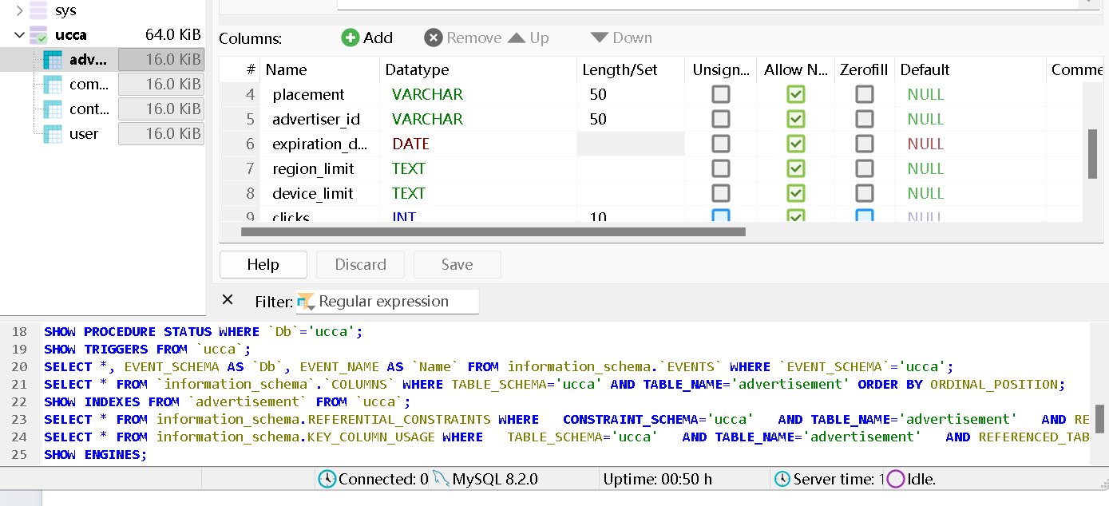

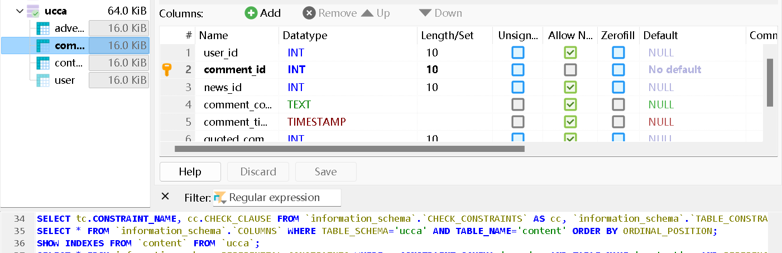

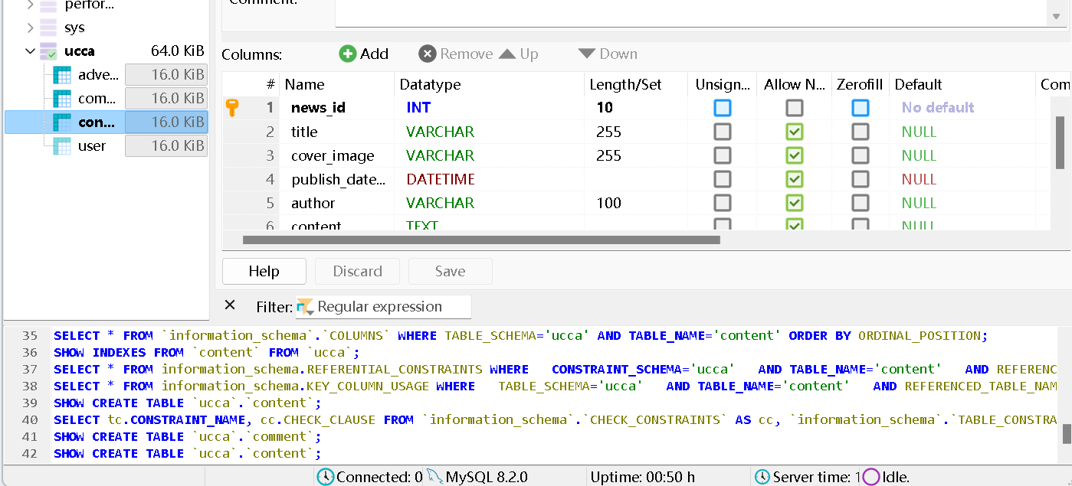

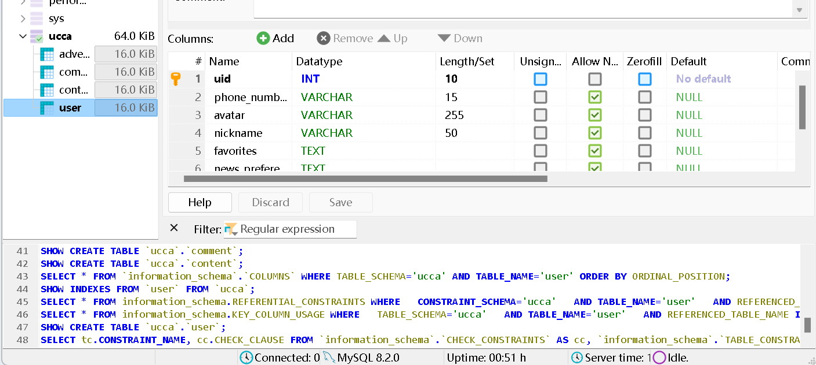

In Intellj IDEA:

